Band = 8.5
The diagram below shows the process for recycling plastic bottles.
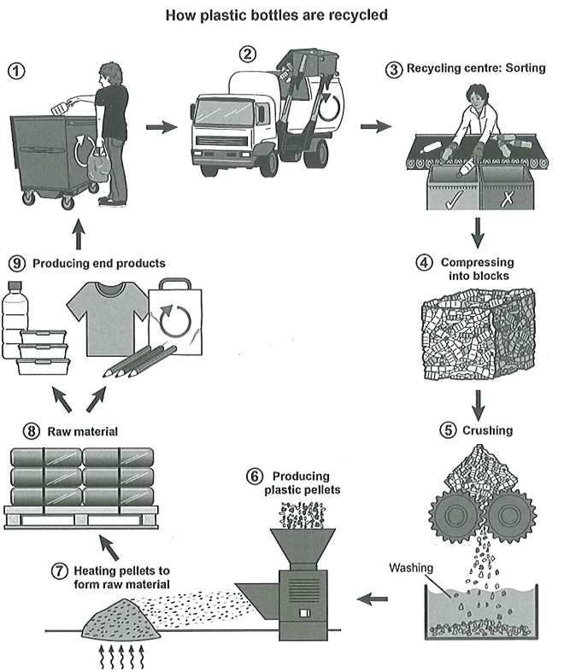
The provided diagram illustrates the sequence of stages involved in recycling plastic bottles.
Overall, the process comprises nine distinct phases, beginning with the disposal of used bottles into collection bins and culminating in the production of new plastic goods, with each stage playing a vital role in achieving the final outcome.
A closer examination revels that the process commences with the discarded plastic bottles are placed into dedicated trash bins, after which they are transported by waste-collection trucks to a recycling facility. During the next stage, the bottles are carefully sorted into recyclable and non-recyclable categories. Following this, the selected bottles are compressed into compact blocks for easier handling.
In the subsequent stage, these blocks are shredded into smaller plastic fragments. The shredded material is then washed thoroughly to remove impurities. Once cleaned, the plastic pieces are fed into a furnace, where they are heated and transformed into pellets. These pellets undergo further processing, after which they can either be converted into raw materials for manufacturing or directly used in the production of new plastic products. Finally, recycled bottles are repurposed into items such as clothing, reusable containers, and shopping bags, thus completing the nine-stage cycle.

